IR Proximity Sensor Interfacing to Arduino:
Introduction:
The IR Proximity sensor is one of the most commonly used sensors. You will find these in automatic taps, automatic door opening, etc. This sensor works on the principle of IR reflectance. There is an IR LED (white / light blue in color) that is constantly emitting IR light. The light when reflected back falls on the IR Receiver LED / Photodiode (the black / dark blue color led). This received signal is then processed by an Op-Amp and the Op-Amp gives a HIGH signal. So the sensor module will give a HIGH signal if there is an object in front of the LED's. The range of sensing can be varied by adjusting the potentiometer on the sensor module. The maximum range of this module is only a few cms, so don't expect to use this as a distance sensor ;). The module will not work when pointed at black objects as black color tends to absorb the IR light.

Requirment:
- IR sensor and it is 3 pin cable.
- Arduino Board
- Breadboard

Hardware configuration:
The IR Sensor. Look at the Wires and Their Mappings. We will connect these accordingly.

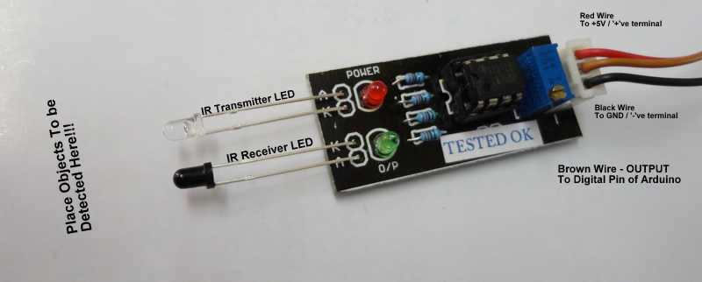

Step1:Connect the Red Wire of the IR sensor to the '+'ve Terminal & the Black Wire of the IR sensor to the '-'ve Terminal
Step2:Connect the Brown wire of the IR sensor to the 8th pin of the Arduino
Step3:The power supply and ground coonnection properly.

Programing:(source code):

Programming to control the IR proximity Sensor.
/*
ULN2003-Buzzer
This program drivea Buzzer using ULN2003
*/

void setup()
{
pinMode(7,OUTPUT);
}
void loop()
{
digitalWrite(7,HIGH);
delay(2000);
digitalWrite(7,LOW);
delay(3000);
}
Installation:
The source code copy to the skeches of arduino and compile (there is verify option) as shown given below.

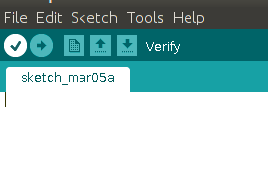

And then uploding the source code.(there is uploding option) to the Arduino board.
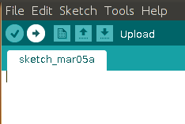

Troubleshooting:
FAQ:
Maintainers:
Duryodhan Aldar (durva.ges@gmail.com)

References: http://quickstartkitforarduino.blogspot.in/

